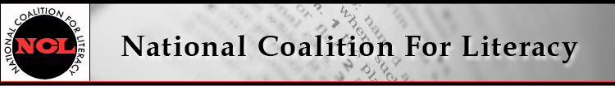

NCL Board Meeting Call in number: 605-477-2100
12 October 2016, 9:30-11:30 AM PIN: 240804#

Expected attendees:
Michele Diecuch, David Hendricks, Silja Kallenbach, Deborah Kennedy, Kristin Lahurd, Tom Nash, Christy Rhodes, Heather Ritchie
Expected absences:
Blaire Willson Toso, Jeff Carter

AGENDA
1. Roll call (Heather)
2. Welcome new members (Deborah)
3. Review/approve minutes of Sept 26 meeting (Heather)
4. Board housekeeping (Deborah)
5. Recap of Sept 27 Members’ Meeting and awards event (Deborah)
6. Finance committee and treasurer’s report (Deborah and Kristin)
7. Policy committee (Deborah)
8. Fall 2016 task groups
- Bylaws/governance (Deborah)
- Membership (Michele)
- Communication (Heather)
- Literacy Caucus (Deborah)
9. New COABE – NCSDAE advocacy partnership (Tom)
10. OCTAE/ETS PIAAC report release event (Deborah)
11. 2017 budget and calendar planning (Deborah)
12. Other business

