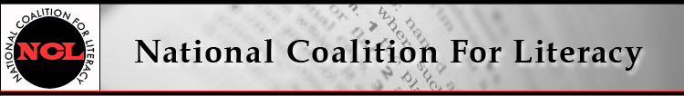

NCL Board Meeting Call in number: 641-715-0861
14 December 2016, 9:30-11:30 AM PIN: 240804#

Expected attendees:
Jeff Carter, Michele Diecuch, David Hendricks, Silja Kallenbach, Deborah Kennedy, Kristin Lahurd, Tom Nash, Christy Rhodes, Heather Ritchie, Blaire Willson Toso

AGENDA
1. Roll call (Heather)
2. Review/approve minutes of October 12 meeting (Heather)
3. Fall 2016 event recap
- AAACE Conference (Deborah, Christy)
- PIAAC prison study release event (Jeff, Deborah)
- Adult charter school event (Jeff, Heather, Silja)
4. Finance committee and treasurer’s report / draft 2017 budget (Kristin)
5. Membership update (Michele)
6. 2017 plans, part 1: NCL internal / general operating
- Bylaws revision (Deborah)
- Management support (Deborah)
- Quickbooks update (Kristin)
- Website / logo refreshment (Deborah)
- Board member recruitment (Deborah)
7. 2017 plans, part 2: Advocacy, communications, outreach
- Federal budget / political context (Jeff)
- Communication about advocacy activities and resources: NCL's role (Deborah, Christy, Heather, with Tom on COABE-NCSDAE plans)
- Outreach
- Betsy DeVos (Deborah)
- OCTAE charter schools initiative (Jeff)
- House Literacy Caucus and Senate champions (Jeff, Deborah)
8. 2017 plans, part 3: Events
- Joint policy call with NAEPDC on Integrated Education & Training (Jeff, Michele)
- Conference presentations - COABE, NAWB, other? (Jeff, Deborah)
- OCTAE/ETS PIAAC report release event (Deborah, Jeff)
- Congressional briefing (Deborah)
- Adult Education and Family Literacy Week and Literacy Leadership Awards (Deborah)
9. Other business

