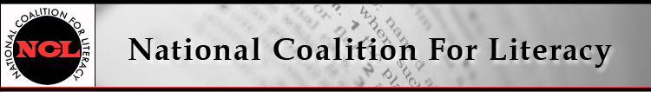

NCL Board Meeting Call in number: 641-715-0861
8 February 2017, 9:30-11:30 AM PIN: 240804#

Expected attendees:
Jeff Carter, Michele Diecuch, David Hendricks, Silja Kallenbach, Deborah Kennedy, Kristin Lahurd, Tom Nash, Christy Rhodes, Heather Ritchie, Blaire Willson Toso

AGENDA
1. Roll call (Heather)
2. Review/approve minutes of December 14 meeting (Heather)
3. Membership update (Michele)
4. Finance committee and treasurer’s report (Kristin)
- Budget update
- Quickbooks update
5. 2017 plans, part 1: NCL internal / general operating
- Procedures (Heather)
- Management support (Deborah)
- Bylaws revision (Deborah)
- Board member recruitment (Deborah)
6. House Adult Literacy Caucus update (Deborah)
7. 2017 plans, part 2: Events, communications, outreach
- Federal budget / policy context (Jeff, Deborah)
- Briefing options (Deborah)
- Conferences (Deborah and all)
~ TESOL Annual Conference (21-24 March, Seattle, WA)
~ NAWB Forum (25-28 March, Washington, DC)
~ VALUEUSA Learner Leadership Institute (3-5 April, Washington, DC)
~ COABE Annual Conference (2-5 April, Orlando, FL)
8. Other business

