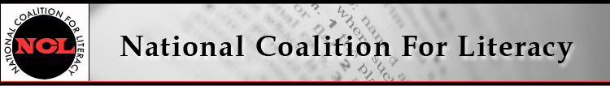

NCL Board Meeting Call in number: 641-715-0861
12 April 2017, 9:30-11:30 AM PIN: 240804#

Expected attendees:
Jeff Carter, Michele Diecuch, David Hendricks, Silja Kallenbach, Deborah Kennedy, Kristin Lahurd, Tom Nash, Christy Rhodes, Heather Ritchie, Blaire Willson Toso

AGENDA
1. Roll call (Heather)
2. Review/approve minutes of February 8 meeting (Heather)
3. Membership update (Michele)
4. Finance committee and treasurer’s report (Kristin)
- Budget update
- Quickbooks update
5. Management support update (Deborah)
6. Events updates and planning
- VALUEUSA Learner Leadership Institute (Deborah)
- COABE conference and thought leaders meeting (Tom, Michele, Deborah)
- COABE Hill Day (late April) (Tom)
- May 18 NCL members' meeting (Deborah, Michele)
- AEFL Week
7. Other business

