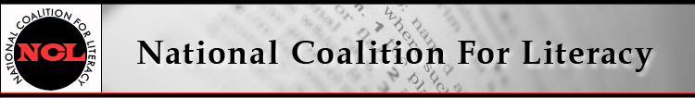

NCL Board Meeting Call in number: 641-715-0861
13 June 2018, 10:00-11:30 AM PIN: 240804#

Expected attendees:
Carol Clymer, Michele Diecuch, David Hendricks, Deborah Kennedy, Kristin Lahurd, Tom Nash, Christy Rhodes, Heather Ritchie
Not attending: Silja Kallenbach
Note taker: TBD

AGENDA

1. Roll call (Christy)
2. Review/approval of minutes of May 9 meeting (Christy)
- Attachment: NCL Board Minutes - May
3. Strategic action (Census) group report (Carol et al.)
4. Review of policy / protocol for NCL position statements
- Attachment: Advocacy and Public Policy Procedures - edited
5. Membership update (Michele)
6. Communications and website update (Heather and Christy)
7. Finance committee update (Kristin)
8. Looking ahead to fall
- AEFL Week, Sept 24-29, and scheduling of fall events
- Literacy Leadership Awards - task force
- Board election (need one new person) - task force

National Coalition for Literacy
2018 CALENDAR OF EVENTS
(updated 6/12/2018)

June
6 | Policy call, 4 PM
13 | Board meeting, 10-11:30 AM
18-20 | TESOL Advocacy and Policy Summit (Washington, DC)
21-26 | ALA Conference (New Orleans)
July
11 | Policy call, 4 PM
18 | Board meeting, 10-11:30 AM
August
8 | Policy call, 4 PM
15 | Board meeting, 10-11:30 AM
September
23-29 | AEFL Week
24-26 | NCFL annual conference, Ft Lauderdale
26 | CEF Gala (evening)
26 | Board meeting, 1:00-3:30 PM, ALA Washington office
26 | Literacy Leadership Awards, 5:30-7:30 PM, Capitol Hill
27 | Members' meeting, 9:00-4:00, ALA Washington office
October
2-5 | AAACE Conference (Myrtle Beach, SC)
10 | Policy call, 4 PM
17 | Board meeting, 10-11:30 AM
November
7 | Policy call, 4 PM
14 | Board meeting, 10-11:30 AM
December
5 | Policy call, 4 PM
12 | Board meeting, 10-11:30 AM

