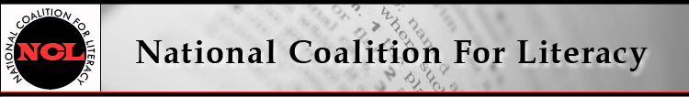

NCL Board Meeting Call in number: 641-715-0861
12 December 2018, 10:00-11:30 AM PIN: 240804#

Expected attendees:
Carol Clymer, Michele Diecuch, David Hendricks, Silja Kallenbach, Deborah Kennedy, Kristin Lahurd, Judy Mortrude, Tom Nash, Christy Rhodes
Not attending:
Note takers: Alex Suchman and Tricia Thompson

AGENDA
1. Roll call (Christy)
2. Introduction of admin support person Tricia Thompson (Deborah)
3. Review/approval of minutes of October 17 meeting (Christy)
Attachment: NCL Board Minutes - October
4. Strategic priorities group report – Census (Carol et al.)
6. Current comment opportunities and activities
- Public charge (ended Dec 10)
- Perkins V (due Dec 24)
- PIAAC conference
7. Membership update (Michele)
8. Finance committee update (Kristin)
9. Looking ahead to 2019 (Deborah)
- COABE panel (Judy)
- Literacy Caucus development (update on Hill support)
- Admin activities: budget planning, membership renewals
- Website and communications planning
- Literacy Leadership Awards task group
National Coalition for Literacy
2019 CALENDAR OF EVENTS
(updated 12/11/2018)

January
2 | Policy call, 4 PM
9 | Board meeting, 10-11:30 AM
February
6 | Policy call, 4 PM
13 | Board meeting, 10-11:30 AM
March
6 | Policy call, 4 PM
13 | Board meeting, 10-11:30 AM
12-15 | TESOL Conference (Atlanta)
31-Apr 3 | COABE Conference (New Orleans)
April
3 | Policy call, 4 PM
10 | Board meeting, 10-11:30 AM

