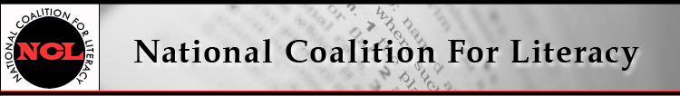

NCL Board Meeting Call in number: 605-515-4802
12 June 2019, 10:00-11:30 AM PIN: 240804#

Expected attendees:
Carol Clymer, Michele Diecuch, Silja Kallenbach, Deborah Kennedy, Kristin Lahurd, Judy Mortrude, Tom Nash, Christy Rhodes
Not attending: David Hendricks
Note taker: Alex Suchman

AGENDA
1. Roll call (Christy)
2. Review/approval of minutes of May 8 meeting (Christy)
Attachment: NCL Board Minutes – May 2019
3. Strategic priorities group report – Census
- Group activities; June 4 webinar and June 10 presentation (Carol et al.)
- Connection with Cathy Hartz at Census Bureau (Deborah)
- Connection with Ed Kissam (Silja, Judy)
- Hill briefing possibility (Deborah)
4. Literacy Caucus update (Deborah)
5. Digital Equity Act update (Deborah)
6. Membership update (Michele)
7. Finance committee update (Kristin)
8. Looking ahead (Deborah)
- AEFL Week and fall members’ meeting
- Literacy Leadership Awards
  - CEF awards
  - Barbara Bush Foundation update
- Board election (and status of certain current Board members)
- Questions for 2020 candidates

