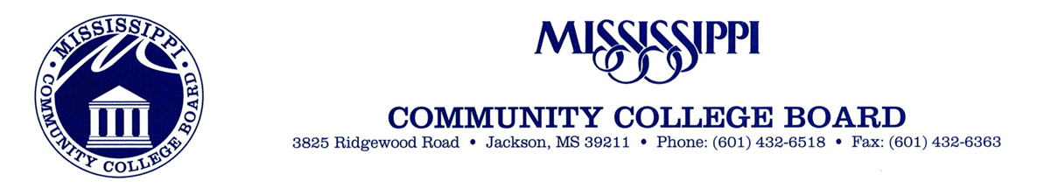
September 2, 2021
To Whom it May Concern:
I would like to take the opportunity to elect Cynthia Bell to serve as a board member on the National Coalition for Literacy board.
Cynthia Bell is the Director of Workforce Development & Numeracy Services at the Literacy Assistance Center, where she oversees workforce projects and initiatives, develops and facilitates workshops for adult basic education (ABE) and high school equivalency (HSE) instructors on standards-based numeracy instruction, as well as on blending academic and workforce skills. When she is not leading and developing trainings, Cynthia is providing customized coaching to instructors on integrated curriculum design, blending workforce and academic instruction, and the best practices of teaching and learning mathematics. In 2016, she co-authored the teacher resource book Teaching Adults: A HiSET Exam Resource Book. Cynthia has presented at international, national, state, and regional conferences, and is an active board member of the Adult Numeracy Network (ANN), an affiliate delegate of the National Council of Teachers of Mathematics (NCTM), and a national LINCS numeracy trainer.
Thank you in advance,
Rachel M. DeVaughan
Rachel M. De Vaughan, Ph.D.

