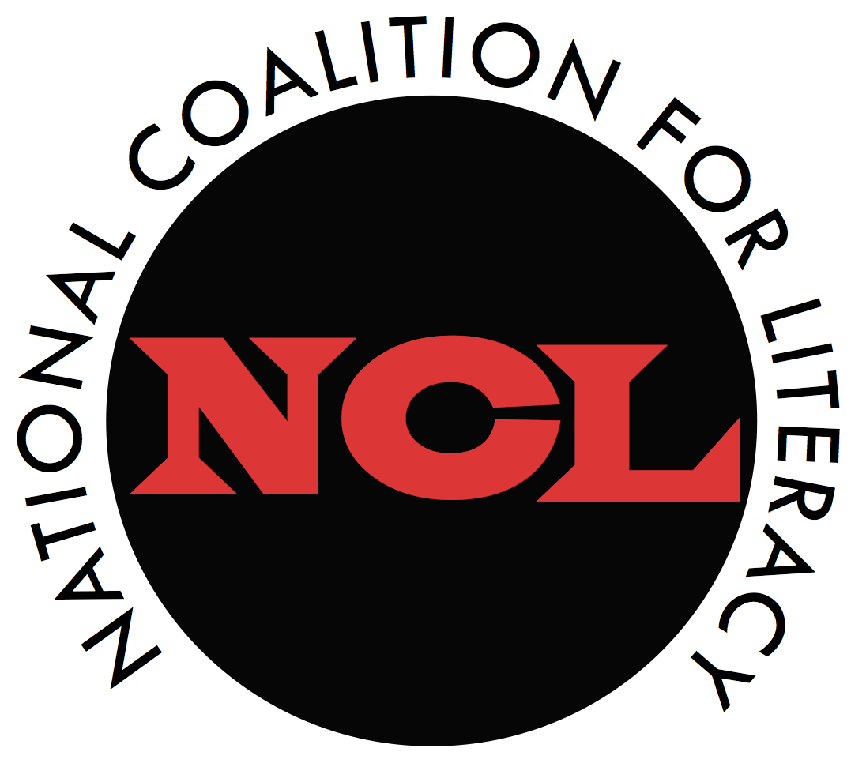 | National Coalition for Literacy
Members Meeting
30 September 2021, 10:00 AM – 3:15 PM Eastern
Join Zoom meeting: https://zoom.us/j/93563011564?pwd=NHRCcy9jeWYxZFQ4eFk1YlNLMWVIZz09
Zoom Meeting ID: 935 6301 1564 Password: 834808

AGENDA

10:00-10:30 President’s Welcome
Executive Director’s report

10:30-11:15 Legislative update with Senate and House staff members
Topics will include current WIOA drafting activities; adult education and family literacy in reconciliation and infrastructure legislation; and the FY 2022 discretionary appropriations process.
Moira Lenehan (Senator Jack Reed)
Katy Rowley (Representative John Yarmuth)
Emily Saleeby (Representative Joe Wilson – tentative)
Others TBD

11:15-12:00 Policy priorities for 2021-2022
- Main WIOA reauthorization
- Adult education in the social safety net

12:00-1:00 Lunch break

1:00-1:45 OCTAE update – Jennifer Mishory, Cheryl Keenan
Topics will include current and planned National Leadership initiatives and other activities.

2:00-3:15 Activity Updates
- Barbara Bush Foundation: preview of National Action Plan (British Robinson, Becky Dyer)
- World Education: new projects (Priyanka Sharma)
- Other member updates (please limit to one major initiative or project)

