NCL 2025 Membership Renewal List
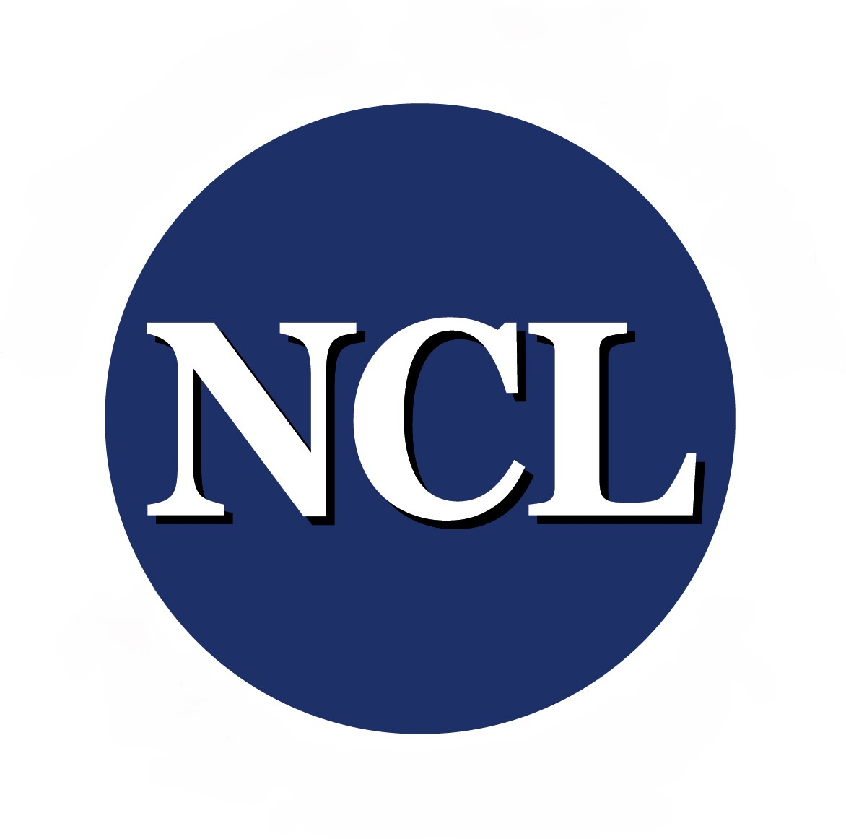

Updated: March 11, 2025

The following organizations have renewed their NCL membership for 2025. All have been invoiced. We have received membership renewal payments from organizations in bold.

Full Member Renewals
National Center for Families Learning
American Association for Adult & Continuing Education
Proliteracy
Literacy Action Network
TESOL
American Library Association
Goodling Institute for Research
Barbara Bush Foundation
COABE
Montgomery Coalition for Adult Education & Literacy
Center for Applied Linguistics
CASAS
The TLP Group
Adult Numeracy Network
Literacy Minnesota/Northstar Digital Literacy
Literacy Assistance Center

Associate Member Renewals
Research Allies for Lifelong Learning
Migration Policy Institute
Pennsylvania Association for Adult & Continuing Education
National Skills Coalition
Arkansas Adult Learning Alliance, Inc.
Mississippi Community College Board
Maine Adult Education Association
Adult Literacy Research Center at Georgia State

We have heard from RTI that they are unable to renew their NCL membership for 2025 because of funding uncertainties and an indefinite freeze on expenditures.

Federico Salas-Isnardi has indicated he has resigned from the Houston Mayor’s Office for Adult Literacy. He reported that the Houston Mayor’s Office may no longer continue their NCL membership because they are going to shift focus to local libraries. They renewed their membership by completing the membership renewal form, but haven’t yet paid their dues. I’ve reached out to the new ‘acting’ director and am awaiting a response as to whether they want to continue their NCL membership.

Philadelphia Office of Children & Families has indicated they are unable to renew this year due to a funding freeze that was put in place until July. They asked to be kept on mailing list in hopes they can renew again next year.

Past member organizations who have not yet renewed their membership:

Full
Jobs for the Future
World Education
WestEd

Associate
Alabama Association for Public, Continuing and Adult Education
AIR
Arizona Association for Lifelong Learning
AALPD
Delaware Division of Libraries
GED Testing Service
Greenville Literacy Association
Maryland Association for Adult & Continuing Education
NASDAE
ScaleLit (Chicago Literacy Coalition)

QUESTION: As NCL embarks on developing a current strategic plan to chart a new path forward, what are your initial thoughts on how NCL can best support the field of adult education and literacy and its members?

Responses:
- By all members working together collaboratively to brainstorm the best path(s) forward.
- Continue with the great work already being done.
- NCL should continue to be a facilitator and convener of policy conversations regarding the adult education and family literacy landscape. This includes helping to coordinate with aligned ALL IN efforts.
- Being the voice of adult education to policy makers.
- We like what you do. Will you be sending us a bill for this? I will need an invoice to pay it and it has gone up substantially so I will need to get board approval to pay it. Thank you.
- Providing regular updates on the state of the field, actionable steps we can take to address issues, and opportunities for collaboration in our work.
- Support greater alignment and amplification of collective programmatic and policy efforts to advance the field, working together with ALL IN and other members.
- Helping coordinate advocacy efforts so that more people will understand that low literacy impacts every aspect of our lives (e.g., health, financial well-being, workforce preparedness, children's success, etc.) We need a consistent voice and message.

